ITA0610 - Machine Learning
EXP-3
Demonstrate the working of the decision tree based ID3 algorithm. Use an appropriate data set for building the decision tree and apply this knowledge to classify a new sample.
Aim
To implement and demonstrate the ID3 (Iterative Dichotomiser 3) Decision Tree algorithm using an appropriate dataset and classify a new sample.

Algorithm
- Import the required libraries.
- Create or load the training dataset.
- Separate the input features and target class.
- Convert categorical attributes into numerical values using Label Encoding.
- Train the Decision Tree classifier using the Entropy (ID3) criterion.
- Provide a new sample for prediction.
- Predict the class label of the new sample.
- Display the predicted result.
PROGRAM:
import pandas as pd
from sklearn.preprocessing import LabelEncoder
from sklearn.tree import DecisionTreeClassifier
data={'Outlook':['Sunny','Sunny','Overcast','Rain','Rain','Rain','Overcast','Sunny','Sunny','Rain','Sunny','Overcast','Overcast','Rain'],
'Temperature':['Hot','Hot','Hot','Mild','Cool','Cool','Cool','Mild','Cool','Mild','Mild','Mild','Hot','Mild'],
'Humidity':['High','High','High','High','Normal','Normal','Normal','High','Normal','Normal','Normal','High','Normal','High'],
'Wind':['Weak','Strong','Weak','Weak','Weak','Strong','Strong','Weak','Weak','Weak','Strong','Strong','Weak','Strong'],
'PlayTennis':['No','No','Yes','Yes','Yes','No','Yes','No','Yes','Yes','Yes','Yes','Yes','No']
}
df = pd.DataFrame(data)
print("Training Data:\n")
print(df)
le = LabelEncoder()
for column in df.columns:
df[column] = le.fit_transform(df[column])
X = df.iloc[:, :-1]
y = df.iloc[:, -1]
model = DecisionTreeClassifier(criterion='entropy')
model.fit(X, y)
new_sample = [[2,1,0,1]]
prediction = model.predict(new_sample)
if prediction[0] == 1:
print("\nPrediction : Play Tennis = Yes")
else:
print("\nPrediction : Play Tennis = No")

OUTPUT:
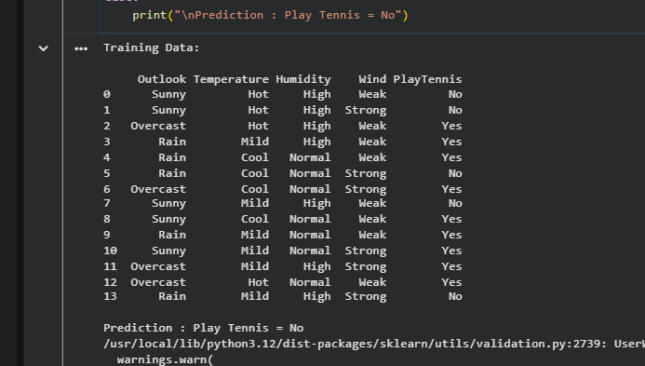

RESULT:
The ID3 Decision Tree algorithm was successfully implemented using Python. The model was trained with the given dataset and correctly classified the new sample as:
Prediction: Play Tennis = Yes
Hence, the ID3 algorithm successfully built a decision tree and classified the new instance based on the learned decision rules.

